Observations:

1. There is less space gap between Login and Email and below of the submit button, there should be more space gap as per wireframe.
2. The name of login button is not as per wireframe.

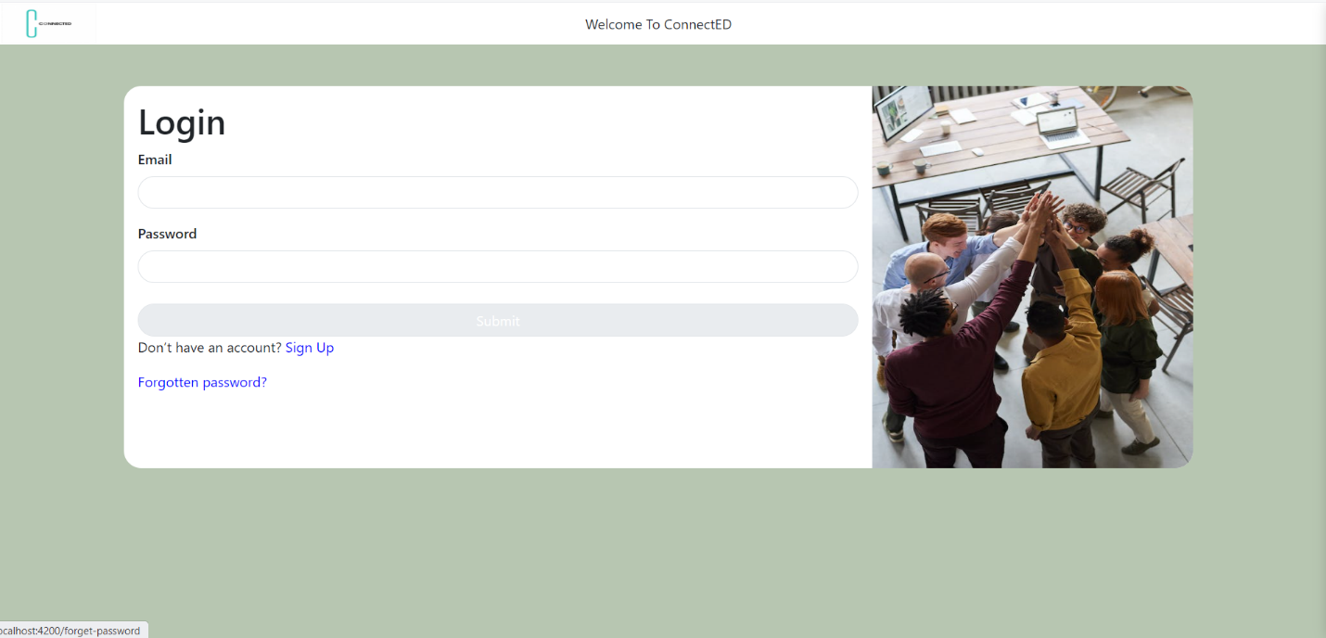Wireframe:

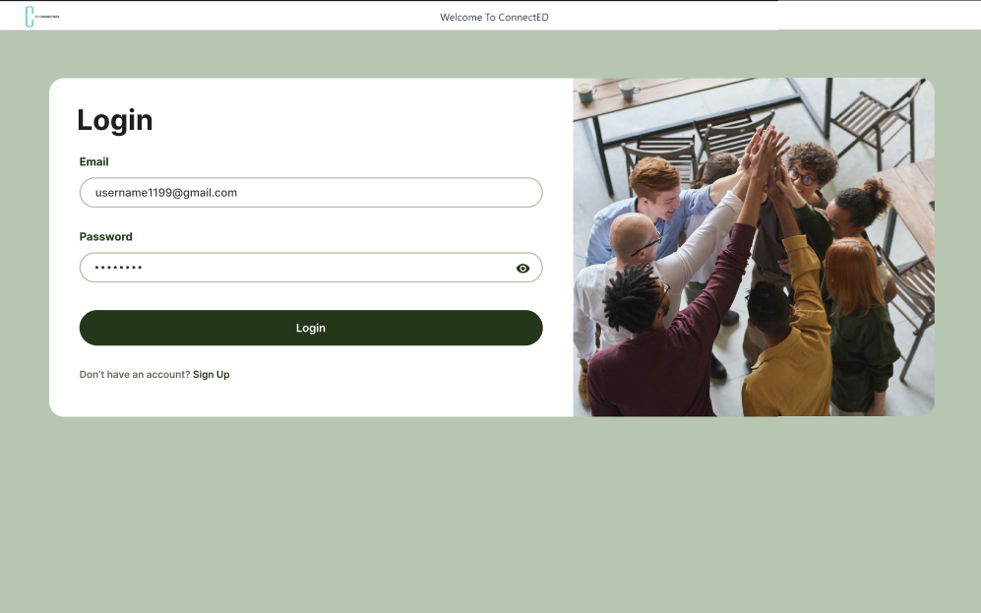

1. The error message should be “invalid credentials” instead of “Check credentials”.

